Control Unit
One of the basic modules for a CPU is the control unit. Our task was to design the control unit with the following functions: sw, lw, beq, bne, j, add, sub, and, or, slt, addi. The implementation provided by lecturer had almost all the functionality implemented except: j, bne, addi. From the MIPS32 instruction sheet we found out the corresponding OP codes for the missing instructions.

Instruction | OP Code (Hex)
J | 0x02
Bne | 0x05
addi | 0x08

J and addi was very easy to integrate in the current design. We were able to use the existing hardware design, however for the bne instruction we had to add some more components to the design. Basically we added another branch data path, called “BranchNE” to the control unit.

Simulation
After we had described the behaviour of the control unit we simulated it with the OP codes for the previously mentioned instructions.
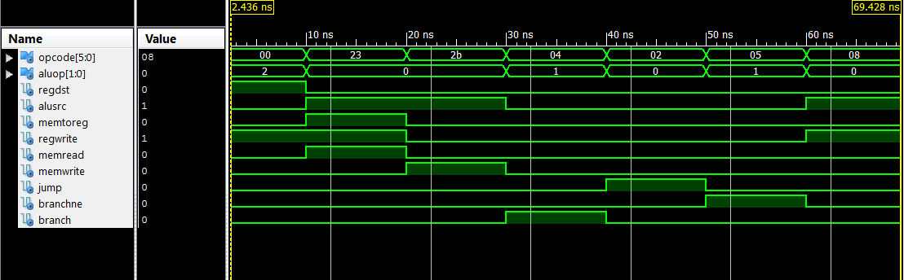

Result
- 0-10ns is R-type instruction
- 10-20ns is load word instruction
- 20-30ns is store word instruction
- 30-40ns is branch if equals instruction
- 40-50ns is jump instruction
- 50-60ns is branch not equals instruction
- 60-70ns is addi instruction

Conclusion
The simulation of the control unit worked just like expected. All the corresponding bits regarding the OP code were set correctly as you can see in the simulation waveform above.

Arithmetic logic unit (ALU)
After we had a working control unit next task was to implement ALU for all the logical operations regarding registers, like adding, subtracting, anding, oring etc. Again the lecturer provided us with a sample ALU VHDL code. This time the provided code had all the functionality necessary for ALU, so we didn’t need to alter it at all. However, we did split the ALU in 3 parts – Sign extender, ALU control unit and ALU, so our final implementation would look like the provided schematic for MIPS32 processor.

ALU control unit
We implemented ALU control unit by following “ControlUnit.docx” document provided by our lecturer. Basically the task of the ALU control unit is to specify what type of arithmetic operation the main ALU has to carry out.
Logical /Arithmetic Operation | ALUCtr[2:0]
and | 000
or | 001
add | 010
sub | 110
slt | 111

Depending on the ALUOp bus provided by Control Unit and the instruction bus we had to implement the following truth table in ALU control unit
opcode | ALUOp | Operation | instr | ALU function | ALUCtr[2:0]
lw | 00 | Load word | xxxxxx | Add | 010
sw | 00 | Store word | xxxxxx | Add | 010
beq | 01 | Branch if equal | xxxxxx | subtract | 110
R_type | 10 | Add | 100000 | Add | 010
 |  | subtract | 100010 | Subtract | 110
 |  | AND | 100100 | AND | 000
 |  | OR | 100101 | OR | 001
 |  | SLT | 101010 | Set on less than | 111

Simulation
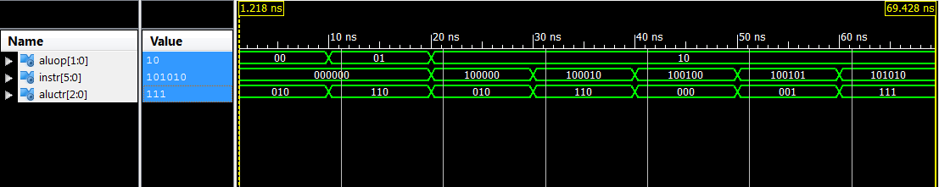

Results
- 0-10ns load/store word instruction
- 10-20ns branch instruction
- 20-30ns add instruction
- 30-40ns subtract instruction
- 40-50ns AND instruction
- 50-60ns OR instruction
- 60-70ns SLT instruction

Conclusion
We can confirm that the simulation worked just like expected. The ALU Control unit generated correct output for every input just like described in the truth table.

Main ALU
The actual arithmetic operations are carried out in the main ALU. For our convenience in this module we integrated one of the MUX provided in the schematic. The one which selects between register files “Read Data 2” output and sign extender output. Once again, the code was more or less provided by the lecturer.

Simulation
We simulated whether the integrated MUX and all the arithmetic functions are working in the ALU.
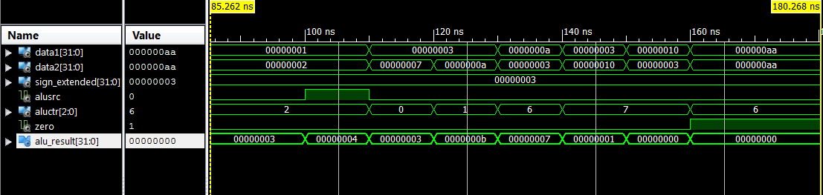

Result
- 85 – 100ns select data2 as input and perform addition
- 100 – 110ns select sign extend as input and perform addition
- 110 – 120ns perform AND operation
- 120 – 130ns perform OR operation
- 130 – 140ns perform subtraction
- 140 – 150ns perform STL operation
- 150-160ns perform STL operation with reversed input
- 160-170ns perform subtraction with identical inputs

Conclusion
Everything worked just like expected. The ALU carried out all the arithmetic operations correctly, and the integrated MUX was performing correctly as well.

Sign Extender
One last component we have to design is sign extender before we can combine the actual CPU. Out lecturer provided with an example sign extender for 8 bit data bus. Only thing we had to change is the BUS width to 32 bits. For our sign extender we used the IEEE numeric_std library.

Simulation
Sign extension HEX result
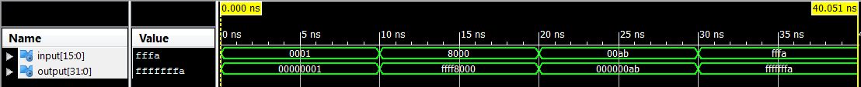
Sign extension Decimal result

Result
- 0 – 10ns extended number 0x0001 to 0x00000001
- 10 – 20ns extended number 0x8000 to 0xffff8000
- 20 – 30ns extended number 0x00ab to 0x000000ab
- 30 – 40ns extended number 0xfffa to 0xfffffffa

Conclusion
As you can see in the two waveforms shown above, the sign extensions between 2 byte number and 8 byte number is working correctly.

Single Cycle Processor implementation
At this stage we have designed all the necessary components for single cycle processor. Our next and final task is to merge everything together and simulate the CPU. We used the following schematic for our implementation:
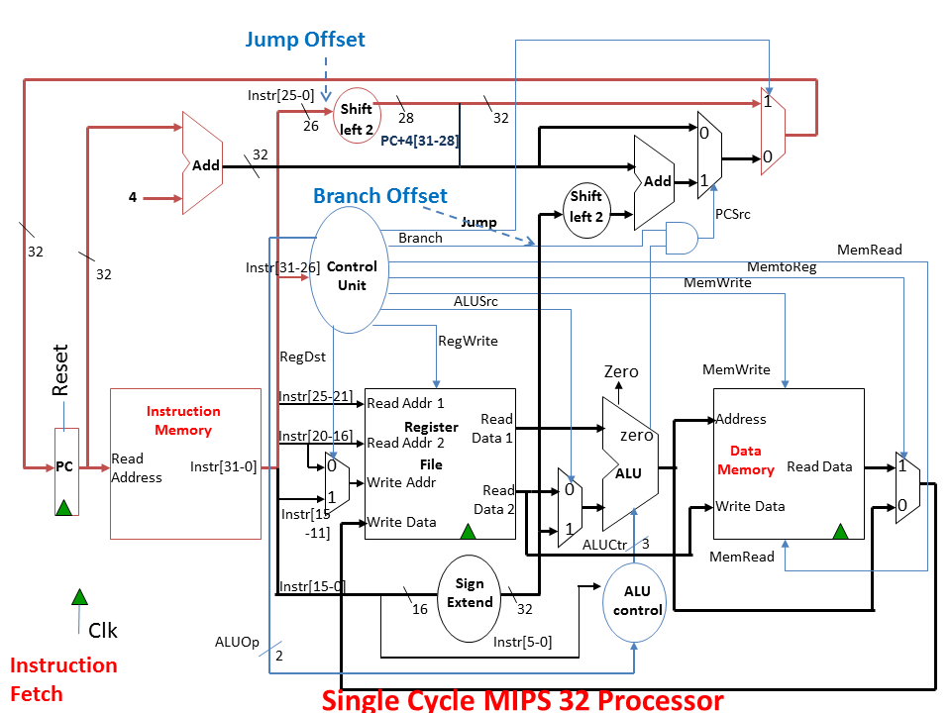

However, as previously mentioned we slightly altered the branching to implement the BNE instruction:
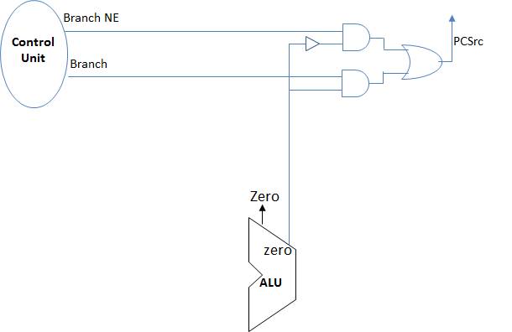

Simulation
After we assembled the CPU with structural VHDL, we then needed a machine code to test whether our implementation and all the components together are working correctly. We designed a test code on MARS, and then just copied the machine code over to our instruction memory.
Only thing we have to alter is the jump address when executing J instruction. MARS starts the code from address 0x00400000. We start the code from the 0th address. BNE or BEQ works fine because they are not jumping to a specific address, but it alters the PC value by the difference between desired address and current address.

1st test code
We wrote a small test code which would test all the instructions our implementation can handle.

Code in MARS
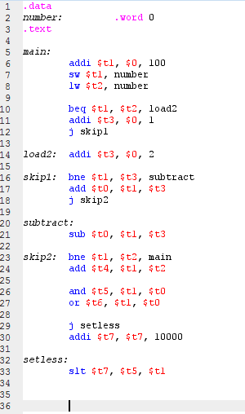

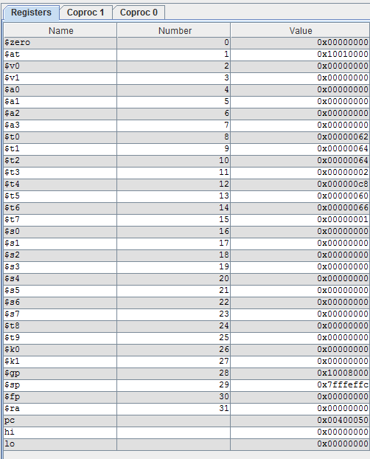
Register values in MARS after execution

Machine code in Xilinx
X"20090064" X"ac290028" X"8c2a0028" X"112a0002" X"200b0001" X"08100009" X"200b0002" X"152b0002" X"012b4020" X"0810000d" X"012b4022" X"152afff2" X"012a6020" X"01286824" X"01287025" X"08000011" X"21ef2710" X"01a9782a"

Register values in Xilinx after execution
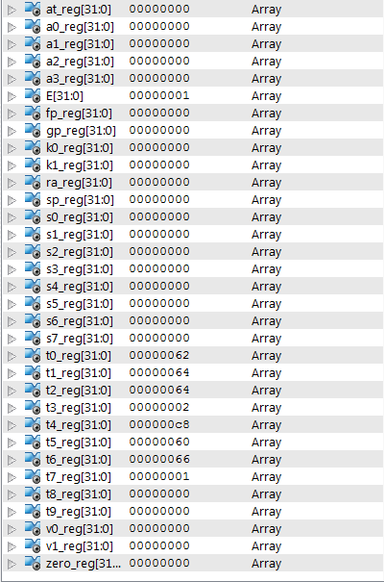

Register value comparison between MARS and Xilinx
Register | MARS | Xilinx
$t0 | 0x62 | 0x62
$t1 | 0x64 | 0x64
$t2 | 0x64 | 0x64
$t3 | 0x02 | 0x02
$t4 | 0xc8 | 0xc8
$t5 | 0x60 | 0x60
$t6 | 0x66 | 0x66
$t7 | 0x01 | 0x01

From the first test code we can confirm that all the necessary instructions have been implemented correctly in our CPU design. We weren’t confident that jumping and branching instruction will work. Despite our pessimism those two instructions were executed correctly.

2nd test code
After we confirmed that all of the instructions are executed correctly, we thought of making another test code for calculating Fibannoci sequence and store it into the memory.

Code in MARS
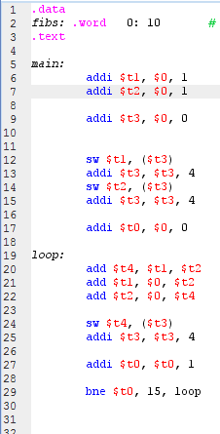

Memory contents in MARS after execution
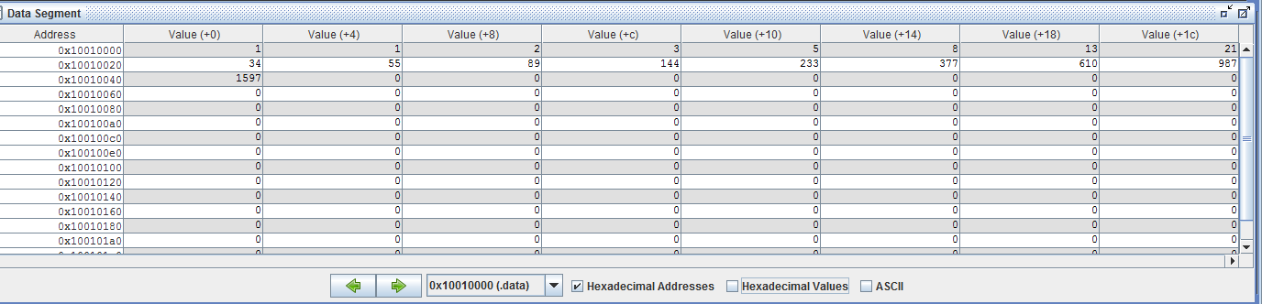

Register values in MARS after execution
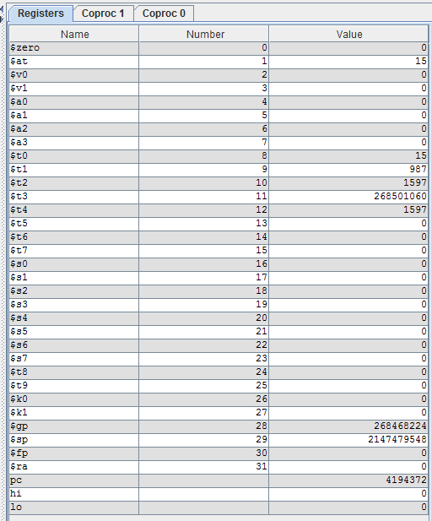

Machine code in Xilinx
X"20090001" X"200a0001" X"200b0000" X"ad690000" X"216b0004" X"ad6a0000" X"216b0004" X"20080000" X"012a6020" X"000a4820" X"000c5020" X"ad6c0000" X"216b0004" X"21080001" X"2001000f" X"1428fff8"

Register values in Xilinx after execution
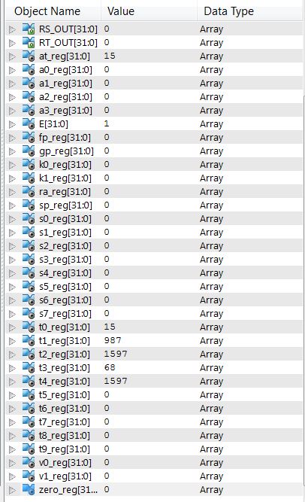
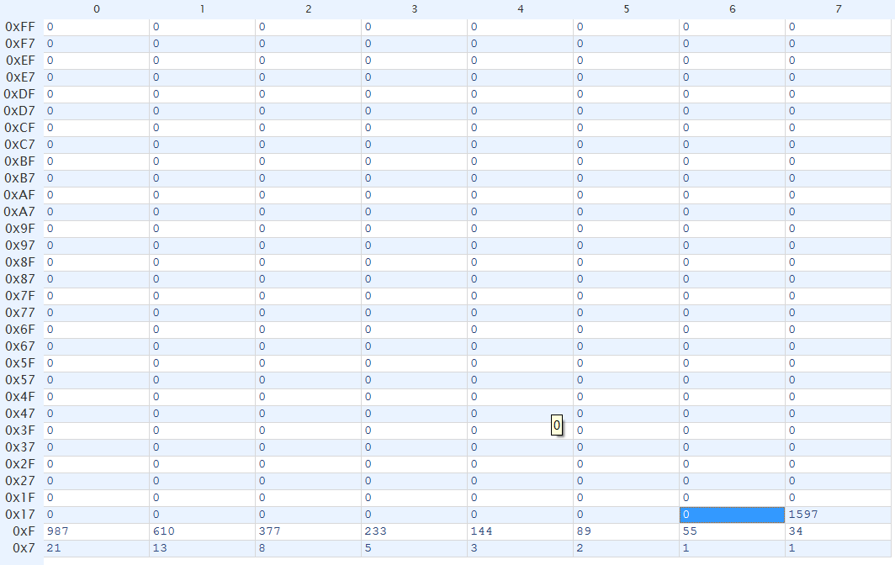
Memory contents in Xilinx after execution

Summary
As you can see in our results, both MARS and Xilinx generated the same Fibannoci sequence up to element 17. That means iterative algorithms are working in our single cycle processor implementation. Only problem we encountered was, that the simulation by default runs for 1 µS, but to generate 17 elements it needs 1.375 µS. Other than that we didn’t have any problems at all.

Conclusion
We successfully managed to implement a working Single cycle processor. For us to be able to accomplish this task we learned a lot of very useful information about how the CPU works. Now we have much better understanding how the CPU works which includes: register file, instruction fetcher, memory, control unit and ALU. We still can further improve this implementation with pipelining and multiple cycles. Current design nowadays is considered to be very slow, since the clock cycle can’t be faster than the slowest instruction, which is SW instruction for our case. Overall, we learned a lot from this coursework and we feel satisfied with what we can now do, and we hope to further improve our understanding how the CPU works with multiple cores.

